Contributor: Charles Yarnoff, Writing Program, csy771@northwestern.edu
Posted: 2011
Comments: Students are often surprised to learn that they can use graphics in a paper to clarify and illustrate key points. I use this handout to explain when and how to use graphics to enhance a paper.

Using Graphics in Research Essays

Graphics include photos, drawings, maps, flowcharts, graphs, and tables. Use a graphic when it will help readers understand a concept (as in the flowchart below) or make a strong emotional impression. Choose these graphics carefully, avoiding ones that are confusing because they have too much text or that are too small to see easily.

Place the graphic next to or below the relevant text. You should also refer to the graphic in the text, pointing out any features you want readers to note. The text right above the stem cell graphic might read, “The process of cultivating stem cells is shown in figure 1 below. The blastocyst (stage two) consists of approximately 150 cells and forms before the embryo can implant into the uterus.”

Under each graphic, include the figure number, a descriptive title, and the source.
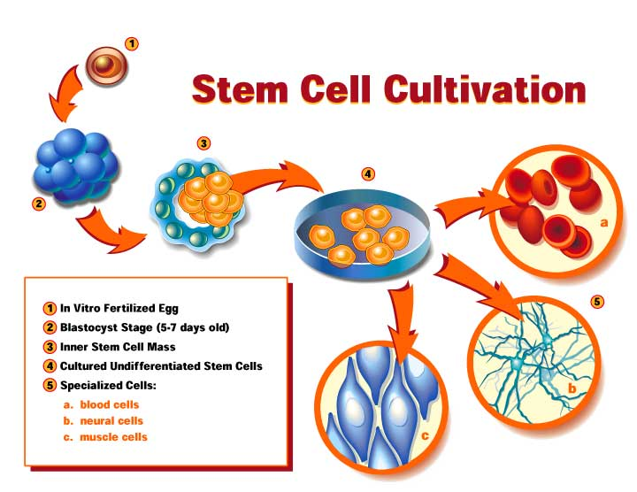
Figure 1: The five stages of stem cell cultivation
Source: University of Wisconsin Madison (http://www.news.wisc.edu/packages/stemcells/illustration.html)

